Image | 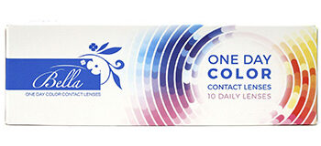
Brand | DIOR
Model Name | BELLA ONE DAY LENSES
Price | RS 1850
PRODUCT DETAILS

